MSSQL Students Lifestyle Data Analysis
Max Min Median:
1) Total Students
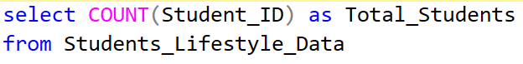
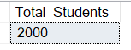
2) Count total Students by Stress Levels
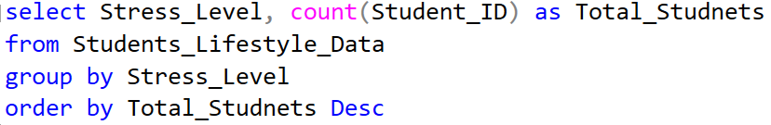
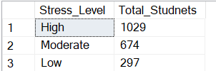
3) Average of CGPA, Study Hours, Sleep Hours, Physical Activity Hours, Extra Curricular Activity Hours, Social Hours
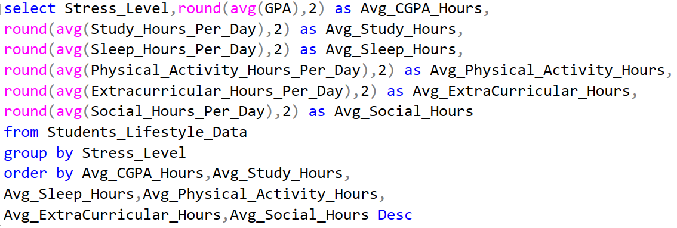
4) Maximum Hours spent by students in Study, Sleep, Physical Activities, Extracurricular Activities, Social Activities and CGPA by Different Stress Levels
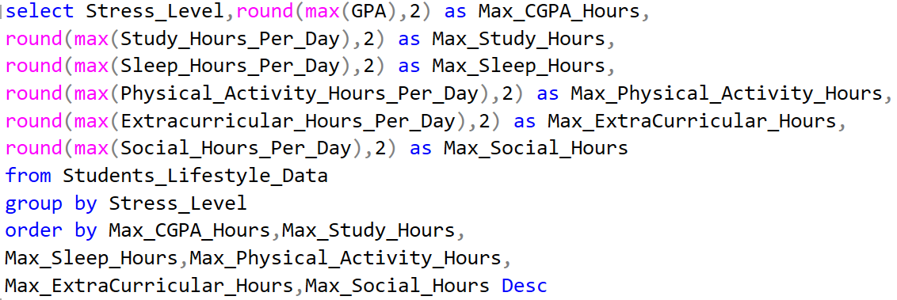
5) Minimum Hours spent by students in Study, Sleep, Physical Activities, Extracurricular Activities, Social Activities and CGPA by Different Stress Levels
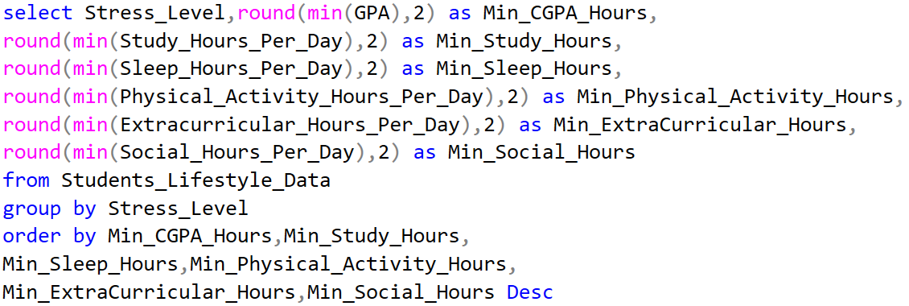
6) Median of CGPA
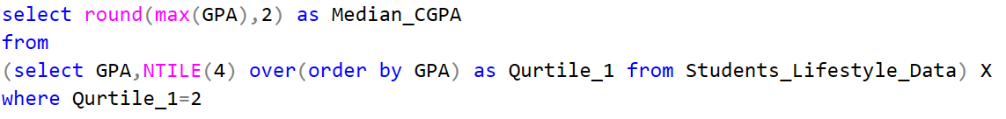
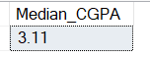
7) Median of Study Hours spent by students
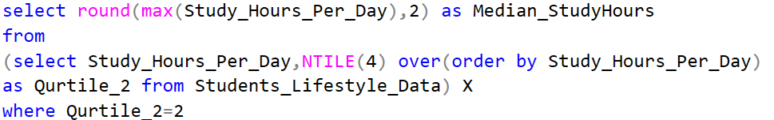
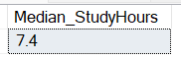
8) Variance of CGPA, Study, Sleep, Physical Activities, Extracurricular Activities, Social Activities Hours spent by students by Stress Levels
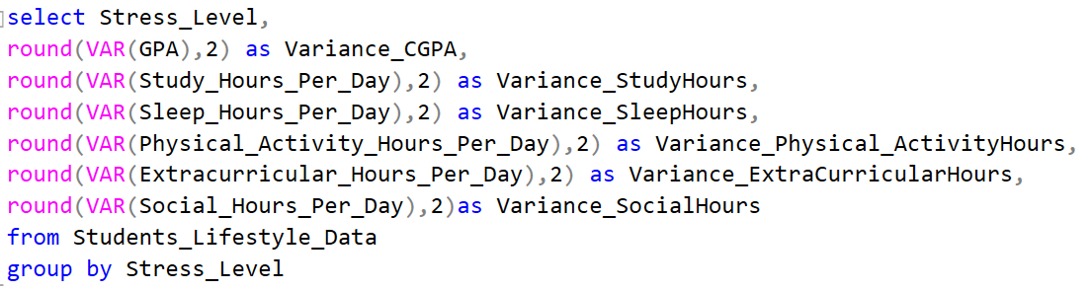
9) Standard Deviation of CGPA, Study, Sleep, Physical Activities, Extracurricular Activities, Social Activities Hours spent by students by Stress Levels
